PROJECT DESIGN PHASE-II
Data Flow Diagram & User Stories
Team Enrollment Confirmation – Import Data using Transform Maps (Spreadsheet)
Date: 30 September 2026
Team ID | SWTID-2026-8331
Team Size | 4
Team Leader | SRIKAVI T
Team Member | ISWARYA S
Team Members | YOGASRI S; KEERTHIKA L

1. Data Flow Diagram
A Data Flow Diagram (DFD) provides a clear graphical representation of how information enters, is processed, transformed, and stored in a system. For this project, the DFD represents the flow of spreadsheet data through the import process and Transform Map into the target table.
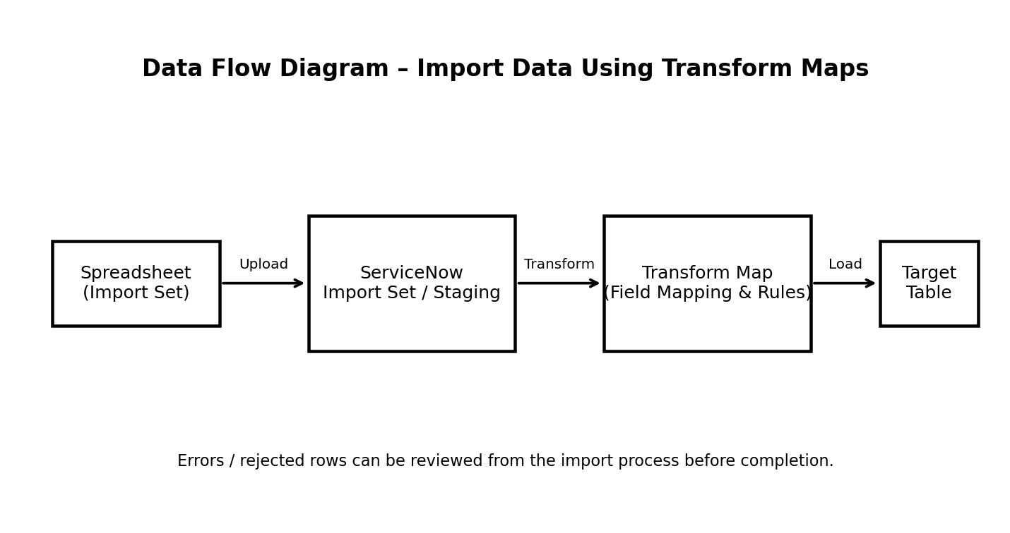
Flow summary: the spreadsheet is uploaded as import data, the records are staged, Transform Map rules map source fields to target fields, and the transformed records are loaded into the target table. Invalid or rejected records can be reviewed and corrected.

2. User Stories
Following the user-story structure in the provided reference, the table below lists functional requirements, user stories, acceptance criteria, priority, and release/sprint.
User Type | Functional Requirement (Epic) | User Story Number | User Story / Task | Acceptance Criteria | Priority | Release
Team Member | Spreadsheet Import | USN-1 | As a team member, I can upload the enrollment spreadsheet into the import process. | The spreadsheet is accepted and the import set is created successfully. | High | Sprint-1
Team Member | Data Validation | USN-2 | As a team member, I can validate the imported spreadsheet data before transformation. | Required fields and invalid records are identified for review. | High | Sprint-1
Team Member | Transform Map | USN-3 | As a team member, I can map spreadsheet source fields to the required target-table fields. | Each required source field is mapped to the correct target field. | High | Sprint-1
Team Member | Transform Rules | USN-4 | As a team member, I can apply transformation rules to imported values. | Configured rules transform the source values correctly before loading. | High | Sprint-2
Team Member | Import Execution | USN-5 | As a team member, I can run the Transform Map and load valid records into the target table. | Valid records are inserted/updated in the target table and processing completes without mapping errors. | High | Sprint-2
Team Member | Error Handling | USN-6 | As a team member, I can identify records rejected during transformation. | Rejected records and relevant error information are available for correction. | Medium | Sprint-2
Administrator | Data Verification | USN-7 | As an administrator, I can verify that transformed enrollment data is present in the target table. | Loaded records match the expected transformed values and required fields. | Medium | Sprint-3
Administrator | Process Completion | USN-8 | As an administrator, I can confirm successful completion of the spreadsheet import process. | Import status is available and successfully processed records can be verified. | Medium | Sprint-3

3. Acceptance Criteria Summary
- Spreadsheet upload must create/import the source records for processing.
- Required fields and invalid values should be identifiable before final loading.
- Transform Map field mappings must correspond to the intended target fields.
- Transformation rules must produce the expected target values.
- Valid records must be loaded into the target table.
- Rejected records and processing errors must be reviewable.
- Administrators must be able to verify the completed import.

4. Conclusion
The proposed DFD and user stories describe the spreadsheet-based import workflow using Transform Maps. They provide a structured view of data movement, transformation, validation, loading, and verification, while defining the expected functionality for team members and administrators.

Reference Basis
This document follows the structure and terminology of the supplied reference document, “Project Design Phase-II – Data Flow Diagram & User Stories,” including its DFD explanation and user-story table format.

